ANDY BAYARDO  
D205 DATA ACQUISITION

PERFORMANCE ASSESSMENT  
13 APRIL 2023

**A. Summarize a research question that can be answered using *both* the original database and the add-on CSV data. The question should require data from *both* these data sources.**

The database for customer churn has tables which contain data on characteristics of each customer. The additional data in CSV form contains data in relation to the customer id number that shows which services the customers have, which include fiber optic, DSL, and none. My question aims to identify which cities have the highest number of customer churn for the past month; Of the total churn number per city, what is the percentage of fiber, DSL, and none in these areas? This query is to identify large numbers of churn and the service composition of those that left the service.

**1. Identify which data from the original data set and the add-on CSV file are needed to answer the research question.**

The tables within the churn database titled customer and location from the original data have the unique customer ID and locational data to retrieve relevant results from the question. The add-on CSV data has the services data. This contains the type of service each customer had at the time of their active service the month prior.

**B. Create a logical data model for the add-on CSV file by evaluating the data contained in the file and emphasizing the relational constraints.**

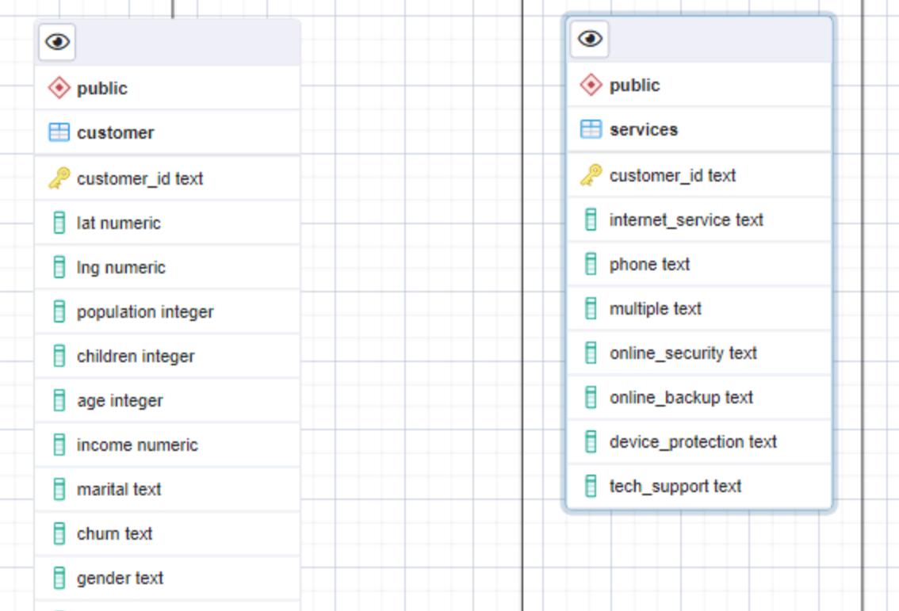

The first column identifying the customer ID will have a key constraint as a public key to uniquely identify each data row and to use for joining with other tables. All the columns will have an attribute constraint of a text data type. The “services” table does not have a direct relationship with the customer table. It is an extension of the customer table which would have a 1:1 relationship.

**1. Write SQL code that creates a table that accommodates the extension of the logical data model to a physical data model by specifying the field types and relevant keys.**

CREATE TABLE services(

customer_id text PRIMARY KEY,

internet_service text,

phone text,

multiple text,

online_security text,

online_backup text,

deive_protection text,

tech_support text

);

**2. Write SQL code that loads the data from the add-on CSV file into the table created in part B1.**  
  
 COPY services(

customer_id,

internet_service,

phone,

multiple,

online_security,

online_backup,

device_backup,

tech_support

)

FROM 'C:\LabFiles\Services.csv'

DELIMITER ','

CSV HEADER;

Reference 1 – Code compiled using information from reference.

**C. Write SQL statement(s) for a query or queries that inform the research question summarized in part A.**

SELECT l.county AS county, l.state, COUNT(DISTINCT cm.customer_id) as total_customer_last_month,

COUNT(CASE WHEN cm.churn = 'Yes' THEN cm.customer_id END ) as churn_count_last_month,

ROUND(AVG(CASE WHEN s.internet_service = 'Fiber Optic' AND cm.churn = 'Yes' THEN 1

WHEN s.internet_service != 'Fiber Optic' AND cm.churn = 'Yes' THEN 0 END), 2)

as churn_percent_fiber,

ROUND(AVG(CASE WHEN s.internet_service = 'DSL' AND cm.churn = 'Yes' THEN 1

WHEN s.internet_service != 'DSL' AND cm.churn = 'Yes' THEN 0 END), 2)

as churn_percent_DSL,

ROUND(AVG(CASE WHEN s.internet_service = 'None' AND cm.churn = 'Yes' THEN 1

WHEN s.internet_service != 'None' AND cm.churn = 'Yes' THEN 0 END), 2)

as churn_percent_only_phone

FROM customer as cm

INNER JOIN location as l

ON cm.location_id = l.location_id

INNER JOIN services as s

ON cm.customer_id = s.customer_id

GROUP BY county, l.state

ORDER by churn_count_last_month DESC

**1. Provide a CSV file or files that capture the results from the query or queries.**  
  
**CSV file attached in submission.**

**D. Determine how often the add-on file should be acquired and refreshed in the database for the data to remain relevant to the business and the research question.**

**From the results of the query on the available data that shows how many customers left the service provider the previous month the add-on data should be refreshed weekly. Each week new customers will be added to the service or existing customers may change their service type. To keep accurate results, it would be best to have this data updated weekly to ensure timely access for monthly or semi-monthly analysis which would be summarized in quarterly reports.**

**E. Create an SQL script that performs the process of loading the add-on data.**

CREATE TABLE services(

customer_id text PRIMARY KEY,

internet_service text,

phone text,

multiple text,

online_security text,

online_backup text,

device_protection text,

tech_support text

);

COPY services(

customer_id,

internet_service,

phone,

multiple,

online_security,

online_backup,

device_backup,

tech_support

)

FROM 'C:\LabFiles\Services.csv'

DELIMITER ','

CSV HEADER;

**F. Provide a Panopto video recording that includes a demonstration of the functionality of the code used for the analysis and a summary of the programming environment.**

**Panopto Video Link Copied into Submission Page**

**https://wgu.hosted.panopto.com/Panopto/Pages/Viewer.aspx?id=a44be8a4-09cf-4431-b9f3-afe300585390**

**G. Record the web sources used to acquire data or segments of third-party code to support the application. Be sure the web sources are reliable.**

**REFERENCES**

*Reference 1.*

*Import CSV File into PostgresSQL Table*. PostgresTutorial.com. Retrieved April 12, 23, from https://www.postgresqltutorial.com/postgresql-tutorial/import-csv-file-into-posgresql-table/